Git Workflow

Definition
# Source: AI Source: Provided by: [Data Path: Persons Table -> ID Column: 1, Name_En Column: Motasem Essam] -> From: [Chatgpt (GPT‑5 Mini)] on [2/19/2026]
Git Workflow is the general process of how developers use Git to manage, track, and share changes in a project, independent of any platform like GitHub or GitLab. It defines how code moves between your local workspace, staging area, local repository, and remote repository and the commands that control those movements.

Git Workflow Image
# Source: Table Source: Provided by: [Data Path: Persons Table -> ID Column: 1, Name_En Column: Motasem Essam] From: [Data Path: Miscellaneous Folder -> Miscellaneous Database -> Miscellaneous Table -> ID: 38] on [2/19/2026]
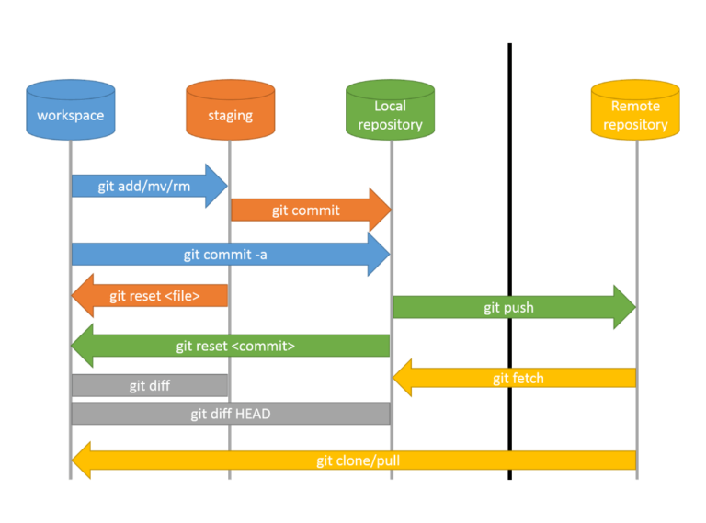

Branch operations
# Source: AI Source: Provided by: [Data Path: Persons Table -> ID Column: 1, Name_En Column: Motasem Essam] -> From: [Chatgpt (GPT‑5 Mini)] on [2/19/2026]

cherry-pick

What is a “cherry-pick”?
# Source: AI Source: Provided by: [Data Path: Persons Table -> ID Column: 1, Name_En Column: Motasem Essam] -> From: [Chatgpt (GPT‑5 Mini)] on [2/19/2026]
In Git, git cherry-pick is a command that allows you to take specific commits from one branch and apply them to another branch, without merging the whole branch.
- Normally, when you merge a branch, you bring in all its commits.
- With cherry-pick, you can select only the commits you want.
Syntax:
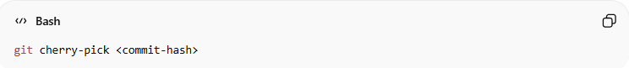
git cherry-pick <commit-hash>

What “relative commits” means
# Source: AI Source: Provided by: [Data Path: Persons Table -> ID Column: 1, Name_En Column: Motasem Essam] -> From: [Chatgpt (GPT‑5 Mini)] on [2/19/2026]
- Relative commits usually refer to commits specified relative to the current HEAD, instead of using their full SHA.
- You can use HEAD~n to refer to commits before the current one:
  - HEAD~1 → one commit before HEAD
  - HEAD~2 → two commits before HEAD, etc.
So if you want to cherry-pick the commit 3 steps behind your current HEAD, you could do:
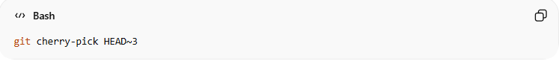
git cherry-pick HEAD~3

Examples
# Source: AI Source: Provided by: [Data Path: Persons Table -> ID Column: 1, Name_En Column: Motasem Essam] -> From: [Chatgpt (GPT‑5 Mini)] on [2/19/2026]
Cherry-pick a single relative commit
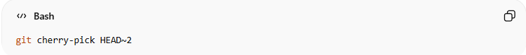
git cherry-pick HEAD~2
- Picks the commit two commits before the current HEAD and applies it to your current branch.
Cherry-pick a range of relative commits
You can pick multiple commits in a range:
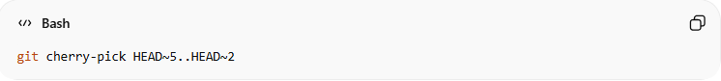
git cherry-pick HEAD~5..HEAD~2
- This picks commits starting from HEAD~5 up to (but not including) HEAD~2.
- Useful if you want a sequence of older commits without taking everything.

Key Notes
# Source: AI Source: Provided by: [Data Path: Persons Table -> ID Column: 1, Name_En Column: Motasem Essam] -> From: [Chatgpt (GPT‑5 Mini)] on [2/19/2026]
- Conflicts can happen just like with merges. You need to resolve them manually.
- Cherry-picking creates new commits on your current branch with the same changes. The commit hashes are different from the original ones.
- Use it to selectively move changes without merging entire branches.

If you want, I can also make a visual diagram showing how cherry-pick works with relative commits, so you can see the commits moving between branches.
Do you want me to do that?

Git Cherry-Pick: Full Explanation and Examples
# Source: AI Source: Provided by: [Data Path: Persons Table -> ID Column: 1, Name_En Column: Motasem Essam] -> From: [Chatgpt (GPT‑5 Mini)] on [2/19/2026]
1️⃣ When you create a new branch
- A new branch starts from the commit where you created it.
- All previous commits up to that point are included automatically.
- Any new commits made after the branch was created are not included.
Example:
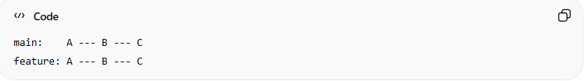
main: A --- B --- C
feature: A --- B --- C
The feature branch starts with all commits from main up to C.

2️⃣ If you make changes on another branch
- Suppose you add new commits D and E on main after the feature branch was created:
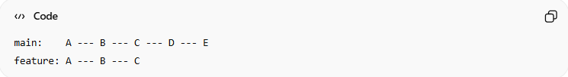
main: A --- B --- C --- D --- E
feature: A --- B --- C
- The feature branch does not automatically have D and E.
- If you want a specific commit (e.g., D) on feature, you use cherry-pick.
- Git will copy the changes from D and create a new commit D’ on the feature branch:
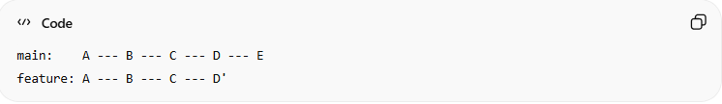
main: A --- B --- C --- D --- E
feature: A --- B --- C --- D'

3️⃣ Why not just merge?
- Merging would bring all commits from main (D and E) into feature.
- Sometimes you only want one specific commit, not everything.
- Cherry-pick lets you take just the commit you want, without merging the whole branch.

💡 Summary
# Source: AI Source: Provided by: [Data Path: Persons Table -> ID Column: 1, Name_En Column: Motasem Essam] -> From: [Chatgpt (GPT‑5 Mini)] on [2/19/2026]
- Cherry-pick = copy a single commit from one branch to another
- The original commit stays where it is
- A new commit is created on your current branch with the same changes and message
- Useful for taking changes made after your branch started or from another branch without merging everything

Git GUI Workflow
# Source: AI Source: Provided by: [Data Path: Persons Table -> ID Column: 1, Name_En Column: Motasem Essam] -> From: [Chatgpt (GPT‑5 Mini)] on [2/19/2026]

GitHub Desktop Workflow
# Source: AI Source: Provided by: [Data Path: Persons Table -> ID Column: 1, Name_En Column: Motasem Essam] -> From: [Chatgpt (GPT‑5 Mini)] on [2/19/2026]

